
Adding Employer/Supervisor
* You will use this to add/set up employers/supervisors so they can evaluate the students.
Step 1: Go to Tracker Tab and under “Teacher Activities” you will click on “Employer/Supervisor WBL Management”


Step 2: Click green plus to “Add New Supervisors”


Step 3: Add the Supervisor/Employer Information, the Name and Email are required.

Step 4: Career Fields- If you would like to sort your supervisors or employers by career fields please choose the type of field.
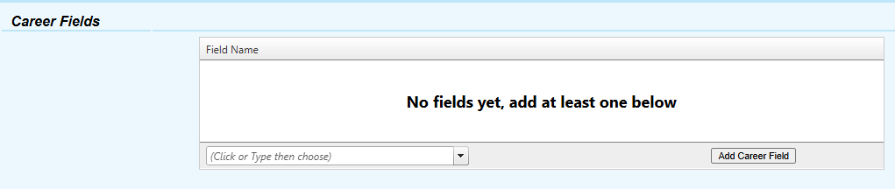

Step 5: Hit “Add New”


